Readme for users.csv

* That file was created in Excel and exported as a csv file.
* By default, it will open with Excel, but you can open it with notepadd++ etc also.
* Cells are inherently spaced by commas.
* This can be used to import users into active directory.
* The first row in Excel correlates to intended AD credentials.
  + ***“First Name,Last Name,Job Title,Office Phone,Email Addess,Description,Organizational Unit”***
* The first columns are basic, but “Organizational Unit” is special
* Go To the Server that is our Domain Controller
  + Dashboard 🡪 Tools 🡪 Active Directory Users and Computers
* The screenshot below, we created 3 organizations units, 2 of them are inside another.

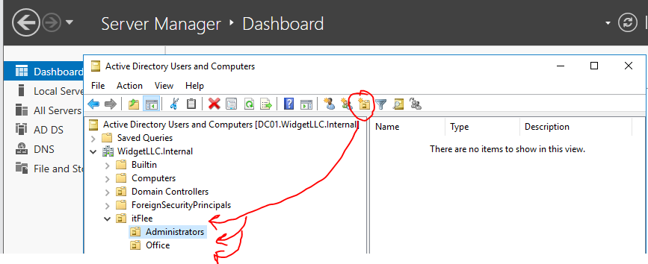

* There are attributes and options that you will not be able to see in our AD details by default.
  + Just go to View, and check Advanced Features.

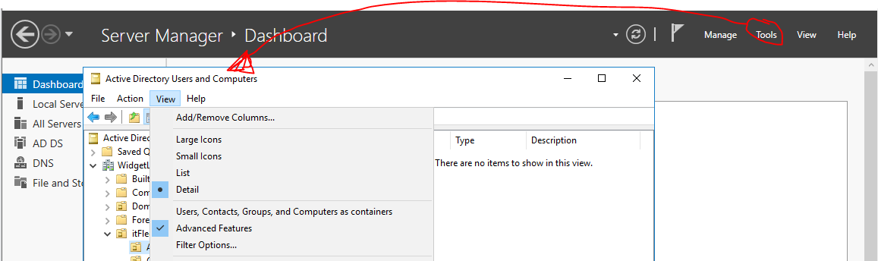

* Now in the screenshot below, we Right Clicked on “Administrators” 🡪 Properties
  + Note, if you do this without first changing the View option above, you will only see 3 tabs in the Properties window, and you will not see the “Attribute Editor” tab.
  + Attribute Editor
    - We do not need to edit anything here right now, we just want to see the Organizational Unit for this group. As you can see, the Attribute name is “distinguishedName”
    - Any person that we will be adding to this Administrators group will need to have this Organizational Unit:
      * OU=Administrators,OU=itFlee,DC=WidgetLLC,DC=Internal
    - This will change for the main group we created itFlee, and the other sub-group Office, but regardless, this is how you see what each OU is supposed to look like.

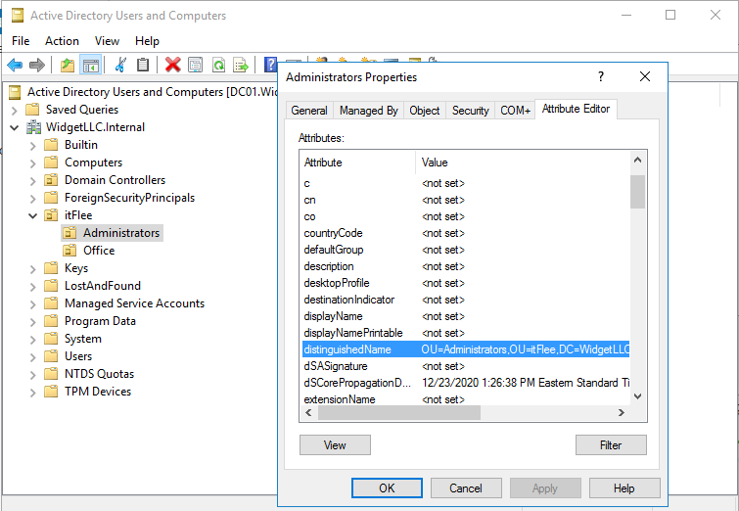

* The excel file:

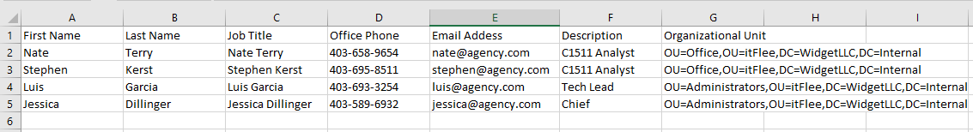

* When exported to a csv

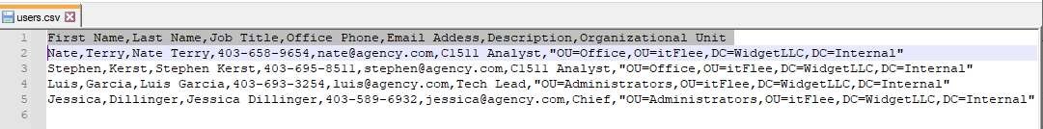

I just moved the users.csv file and the usersAddToAD.ps1 into our DC01 which is our server/Domain Controller which is in charge of our VM-activedirectory.

Screenshot below, we have the csv file at the top, are going to call our ps1 file from ISE in the middle, and you can see in our active directory on the bottom that there are no users, as seen in Office, or in Administrators.

Note – if you run the file, and works fine, you still will need to click the “Refresh” button in the AD to see the new users.

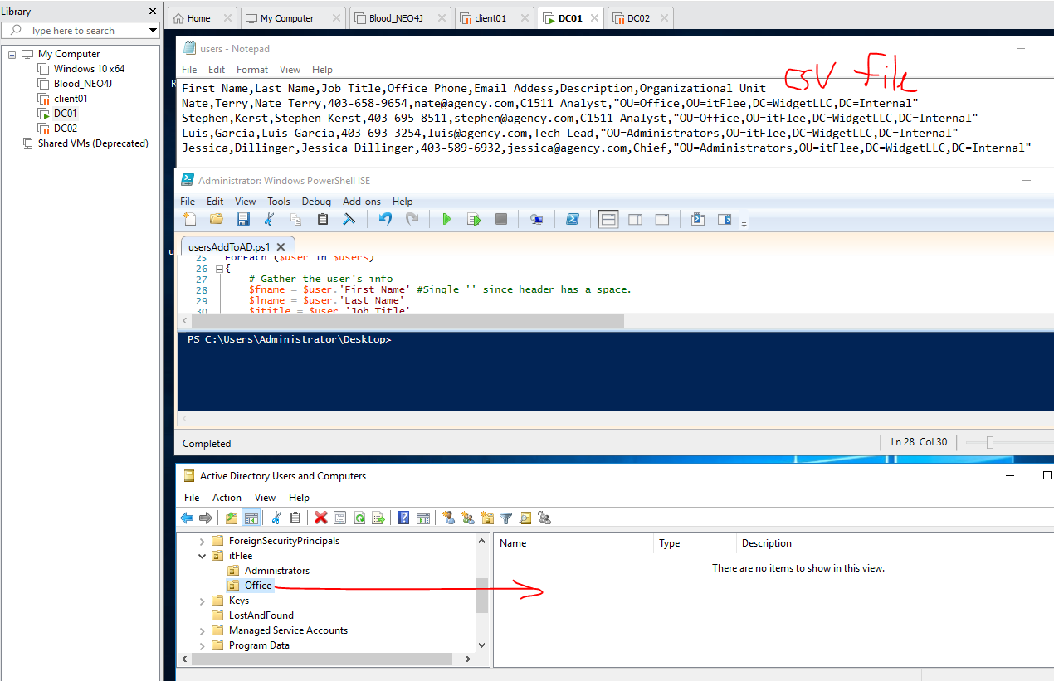



Program asks where the csv file is:

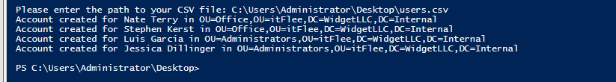

After we run the script and click refresh in the AD, we have our 4 users, seen here in ‘Office’ and the other two in Administrators.

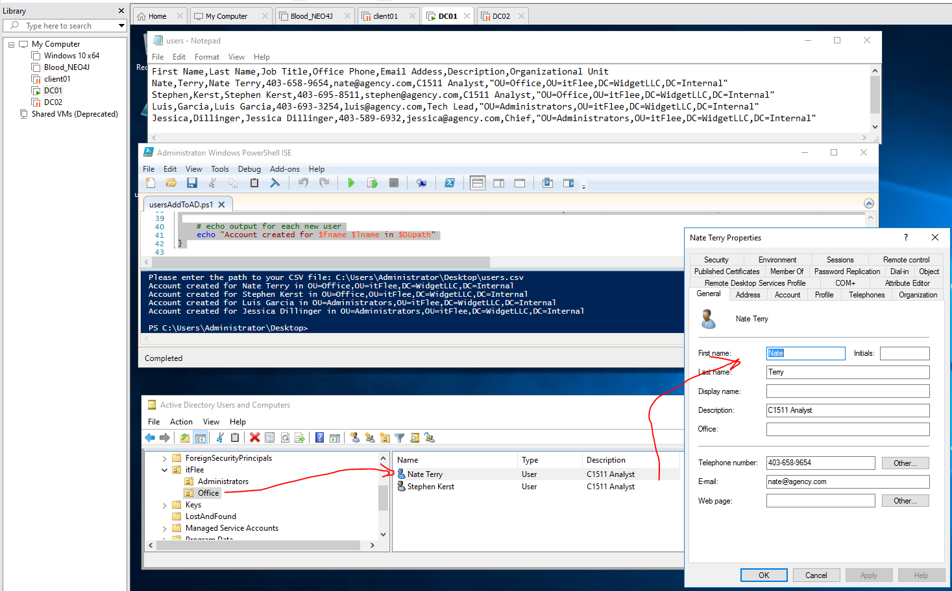

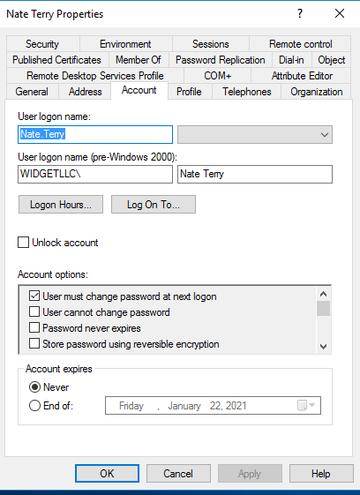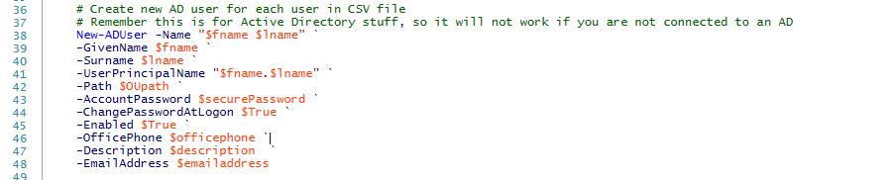

The command above, is in the middle of the PS1 file that we ran.

We have the backticks which lets us drop lines in the same

PowerShell command. All lines are part of the same

New-ADUser command, just each one is a different

attribute in each Active Directory user that we are adding.

There are simple attributes like the names, but as you can see

by the screenshot to the right, that there are many aspects

other than just text that we can add/adjust such as a

user’s password, and if it needs to be changed at their

next logon, which we indicated in the code by setting that

built-in attribute to $True.